COMMUNICATION PROTOCOLS

UART COMMUNICATION PROTOCOL:

UART stands for Universal Asynchronous Receiver Transmitter. It is a serial communication device and usually converts parallel to serial data conversion when it receives the data and transmits it further ( transmission side ) and converts serial to parallel data conversion when it collects the data which is transmitted ( receiving side ). The main purpose of UART is to transmit and receive serial data.

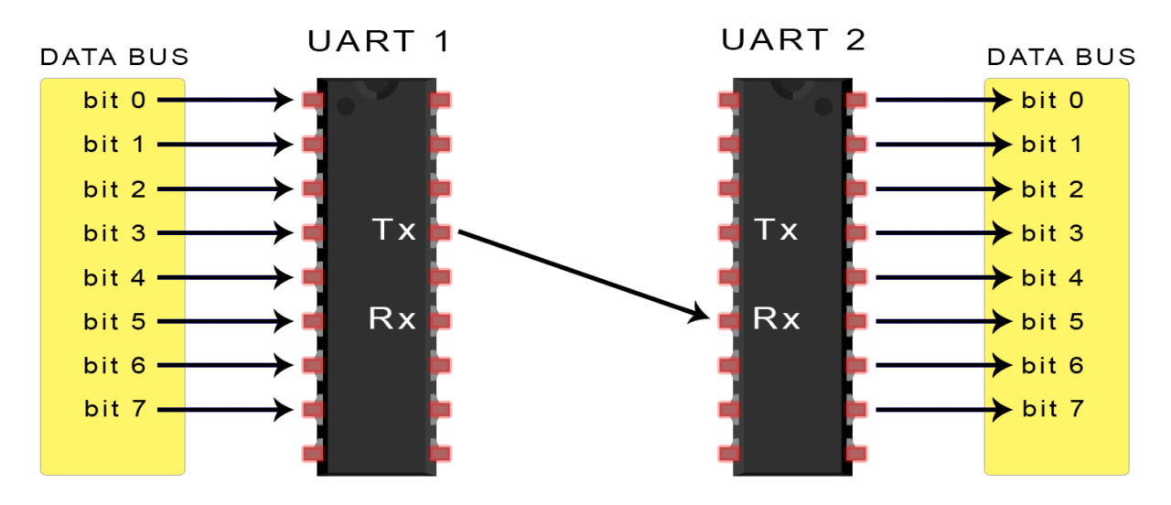

The above pictorial representation shows the basic UART principle, the transmitting UART ( UART 1 in picture ) takes the parallel data input from units like CPU and is then able to convert all this parallel data into serial data. The Tx of the UART-1 is connected to Rx of the UART-2. In the UART-2 we notice that the serial data which is received from UART-1 is converted into parallel data output for the receiving device. We need only two wires for UART type communication.

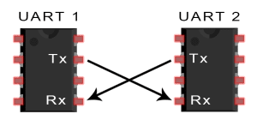

As shown in the above image, the Tx pin transmits serial data and the from the transmitting UART and Rx pin receives the serial data on the receiving UART.

The UART does not have a special clock between the transmitter and the receiver so as to synchronize the data transfer instead they use special bits at the beginning and at the end of the data transfer which indicate the start and the end of the data that is being transmitted between UART’s.

**WORKING:**

1. Data transfer between the UART’s takes place by a data bus.
2. Data is transferred from units like CPU or memory in a parallel data bus to the UART-1.
3. The UART adds a starting bit, ending bit and parity bit on the data bus which forms a data packet.
4. Data Packet is transferred serially from UART-1 to UART-2. The transfer takes place in a bit by bit method.
5. The receiving UART reads the data packet at Rx pin of the receiving UART.
6. The receiving UART first removes the start bit, end bit ad parity bit and converts the data back into parallel form.
7. The data transfer takes place on the UART in parallel form to other devices

STRUCTURE OF A DATA PACKET

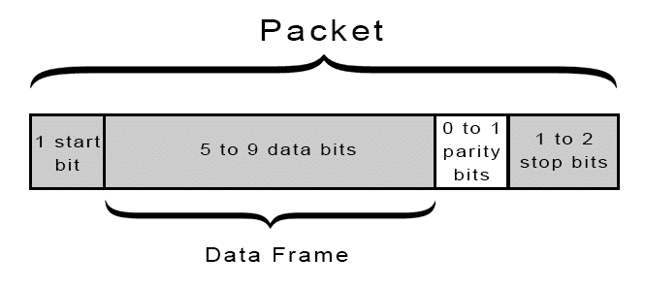

We will examine the data packet by looking at each component.

1. Start bit – It is placed at the beginning of the data packet, it is kept at HIGH voltage level when data is not being transferred but changes to LOW voltage level when data transfer begins. When the Rx pin of the receiving UART detects a LOW voltage level it starts to read the data. The HIGH bit is (1) and LOW bit is (0).
2. Stop Bit – It is placed at the end of the data bus and is two bits long, usually only one bit is used to make a HIGH voltage level. When the Rx pin detects a HIGH voltage level again it stops receiving the data.
3. Parity Bit – It is placed before the stop bit and it is a method to check if the data received is correct or incorrect. Parity bit consists of an even bit or an odd bit. If parity bit is zero ( even parity ) and if parity bit is one ( odd parity ). When the parity bit matches with the data bit, we say that the data is transferred correctly. Inaccurate data transmission can is caused due to long distances, radiations etc.
4. Data Frame – It is the actual data that is being transferred. The bit can vary from 5 bits to 8 bits. It can be 9 bits if the parity bit is not included. It uses LSB type transmission which means Least Significant Bit is sent first in the data frame.

ADVANTAGES OF UART:

1. Clock is not used for data transfer.
2. It contains a parity bit which checks for errors.
3. It only requires 2 wires only for transmission and receiving.

DISADVANTAGES OF UART:

1. UART is serial transmission framework which is slower than parallel method of transmission.
2. Size of data bit is limited to 9 bits.
3. Multiple slave system is not supported in UART.

I2C COMMUNICATION PROTOCOL:

I2C stands for Inter-Integrated Circuit which is a combination of features of SPI and UART. We can connect one master to multiple slaves and we can also connect multiple masters and multiple slaves at one time

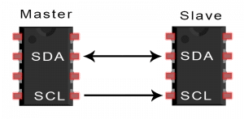

SDA (Serial Data) – The line for the master and slave to send and receive data

SCL(Serial Clock) – It controls clock signal

Data is transferred bit by bit along the single wire line of SDA.

I2C Protocol has been developed by Philips semiconductors for the transfer of data between one central processor and multiple ICs on the same circuit board that too with only two wires. I2C is used in controlling displays, IoT based devices and some sensors due to its simple nature. It is a serial communication protocol.

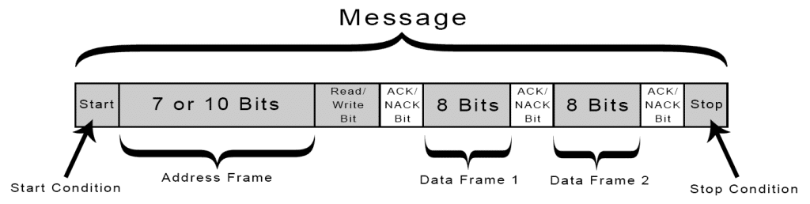

12C DATA FRAME

Start Condition – The SDA line switches from high voltage to low voltage before the SCL clock line switches from high to low voltage.

Stop Condition – The SDA line switches from low voltage to high voltage after the SCL clock line switches from low to high voltage.

Address Frame - A 7 or 10 bit sequence unique to each slave that identifies the slave when the master wants to talk to it.

Read/Write Bit – This bit identifiyes if the master is sending data for reading (low voltage level) or is requesting data from the component(high voltage level).

ACK/NACK Bit – ACK bit is known as the acknowledgment bit. If the data which is sent from the master is received by the slave it sends back a ACK bit else it sends back a NACK bit if the data is not received.

Data Frame 1,2 – After the first ACK bit is received the data is ready to be sent to the slave. The data frame is 8 bit long and after complete transfer of 8 bits, again a ACK/NACK Bit is sent to the master which indicates successful transfer of data.

WORKING OF I2C PROTOCOL

1. The master sends the start condition to the connected slaves by setting SDA line from high voltage to low voltage before the clock line goes from high to low.
2. The master sends 7 to 10 bit messages to the slave it wishes to communicate along with the read/write bit.
3. Each slave compares the address sent by the master to its own address. If the address is matching the slave sends an ACK (acknowledgment bit) and turns SDA line to low else if the address does not match the SDA line is left high.

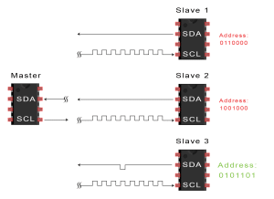

1. The master then sends out or receives the data frame.
2. After the data is sent the master, it sends out the ACK Bit to the device which was sending data. This ACK Bit means that the data is successfully received.
3. The master gives stop condition to stop data transfer by switching SCL to high and SDA to high.

SINGLE MASTER MULTIPLE SLAVES

In the I2C Data frame, we notice that the address frame is a 7 bit and thus it can create unique addresses for multiple slaves. Connections are made in parallel to each other by connecting SDA and put a pull-up resistor while connecting to Vcc.

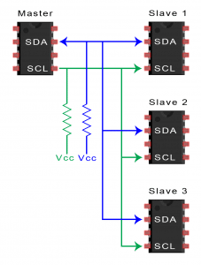

MULTIPLE MASTER MULTIPLE SLAVES

Multiple masters can be connected to a single slave or multiple slaves. The problem with multiple masters in the same system comes when two masters try to send or receive data at the same time over the SDA line. To solve this problem, each master needs to detect if the SDA line is low or high before transmitting a message. If the SDA line is low, this means that another master has control of the bus, and the master should wait to send the message. If the SDA line is high, then it’s safe to transmit the message.

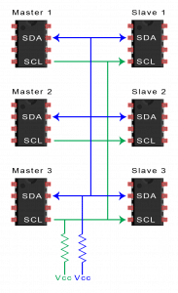

ADVANTAGES OF I2C COMMUNICATION:

1. We can connect multiple master and multiple slaves.
2. ACK/NACK are in place to check for transmission errors.
3. Less complicated than UART.
4. Less wires required (only 2).

DISADVANTAGES OF I2C COMMUNICATION:

1. Data frame is 8 bits long.
2. Slower than SPI protocol.
3. Complex than SPI protocol.

**SPI COMMUNICATION PROTOCOL**

Devices communicating via SPI are in a master-slave relationship. The master is the controlling device (usually a microcontroller), while the slave (usually a sensor, display, or memory chip) takes instruction from the master

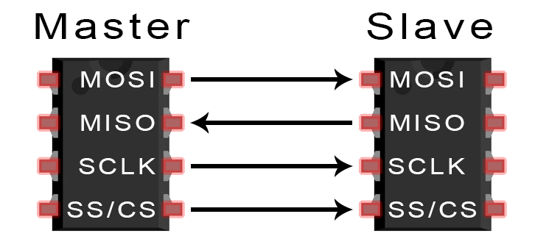

**MOSI (Master Output/Slave Input)** – Line for the master to send data to the slave.

**MISO (Master Input/Slave Output)** – Line for the slave to send data to the master.

**SCLK (Clock)** – Line for the clock signal.

**SS/CS (Slave Select/Chip Select)** – Line for the master to select which slave to send data to.

The clock signal synchronizes the output of data bits from the master to the sampling of bits by the slave. One bit of data is transferred in each clock cycle, so the speed of data transfer is determined by the frequency of the clock signal. SPI communication is always initiated by the master since the master configures and generates the clock signal.

**SLAVE SELECT**

The master can choose which slave it wants to talk to by setting the slave’s SS/CS line to a low voltage level. In the idle, non-transmitting state, the slave select line is kept at a high voltage level. Multiple CS/SS pins may be available on the master, which allows for multiple slaves to be wired in parallel. If only one CS/SS pin is present, multiple slaves can be wired to the master by daisy-chaining.

The master sends data to the slave bit by bit, in serial through the MOSI line. The slave receives the data sent from the master at the MOSI pin. Data sent from the master to the slave is usually sent with the most significant bit first.

The slave can also send data back to the master through the MISO line in serial. The data sent from the slave back to the master is usually sent with the least significant bit first.

STEPS OF WORKING :

1. The master outputs the clock signal and decides the frequency.
2. The master switches the SS/CS pin to a low voltage state, which activates the slave.
3. The master sends the data one bit at a time to the slave along the MOSI line. The slave reads the bits as they are received.
4. If a response is needed, the slave returns data one bit at a time to the master along the MISO line. The master reads the bits as they are received.

ADVANTAGES:

1. Higher data transfer rate than I2C (almost twice as fast)
2. Separate MISO and MOSI lines, so data can be sent and received at the same time
3. No start and stop bits, so the data can be streamed continuously without interruption
4. No complicated slave addressing system like I2C

DISADVANTAGES:

1. Uses four wires (I2C and UARTs use two)
2. No acknowledgement that the data has been successfully received (I2C has this)
3. No form of error checking like the parity bit in UART
4. Only allows for a single master

WIRELESS COMMUNICATION PROTOCOLS

BLUETOOTH

A standard for the short-range wireless interconnection of mobile phones, computers, and other electronic devices. The main function of the Bluetooth technology is that permits you to connect a various electronic devices wirelessly to a system for the transferring of data. Cell phones are connected to hands free earphones, mouse, wireless keyboard. By using Bluetooth device the information from one device to another device. This technology has various functions and it is used commonly in the wireless communication market.

Working

Bluetooth sends and receives radio waves in a band of 79 different frequencies (channels) centered on 2.45 GHz, set apart from radio, television and cellphones, and reserved for use by industrial, scientific and medical gadgets. Bluetooth’s short-range transmitters have very low power consumption and are more secure than wireless networks that operate over longer ranges, such as Wi-Fi.

Applications

Bluetooth is a global 2.4 GHz personal area network for short-range wireless communication. Device-to-device file transfers, mobile credentials, wireless speakers and wireless headsets are often enabled with Bluetooth.

Bluetooth v4

Bluetooth v4 is the latest version of bluetooth and it is used in a wide variety of applications. It has essentially the same structure and services as previous bluetooth versions with the exception of support for low power sensor applications with fast startup.

Broadcast Radio

The first wireless communication technology is the open radio communication to seek out widespread use, and it still serves a purpose nowadays. Handy multichannel radios permit a user to speak over short distances, whereas citizen’s band and maritime radios offer communication services for sailors.

Mostly an audio broadcasting service, radio broadcasts sound through the air as radio waves. Radio uses a transmitter which is used to transmit the data in the form of radio waves to a receiving antenna (Different Types of Antennas). To broadcast common programming, stations are associated with the radio N/W’s. The broadcast happens either in simulcast or syndication or both. Radio broadcasting may be done via cable FM, the net and satellites. A broadcast sends information over long distances at up to two megabits/Sec (AM/FM Radio).

Radio waves are electromagnetic signals that are transmitted by an antenna. These waves have completely different frequency segments, and you will be ready to obtain an audio signal by changing into a frequency segment.

For example, you can take a radio station. When you are listening to 94.3 RADIO ONE, it means that signals are being broadcasted at a frequency of 94.3 megahertz, which also means the transmitter at the station is periodic at a frequency of 94.300,000 Cycles/second.

When you would like to listen to any radio station, all you have to do is tune the radio to just accept that specific frequency and you will receive perfect audio reception.

LoRa(LONG RANGE)

LoRa Technology is the DNA of IoT, connecting sensors to the Cloud and enabling real-time communication of data and analytics that can be utilized to enhance efficiency and productivity. LoRa Technology is a choice for LPWAN connectivity for long range, low power Internet of Things (IoT) solutions, enabling countless use cases in a number of key markets including smart cities, buildings, agriculture, metering etc.The image below is a LoRa module.

